FOR IMMEDIATE RELEASE: March 25, 2020

MEDIA CONTACT:
Mary McCarthy
Women’s Small Business Accelerator Inc.
(614) 414-2449
Mary@WSBAOhio.org

WSBA Launches Business Crisis Team to Support
Women Business Owners During the COVID-19 Pandemic

COLUMBUS, OHIO -- The Women’s Small Business Accelerator (WSBA) today announced the launch of the WSBA Business Crisis Team. Comprised of experienced business owners and professionals, the team provides coaching, reassurance and support to women business owners, in Central Ohio, facing challenges created by the COVID-19 pandemic.

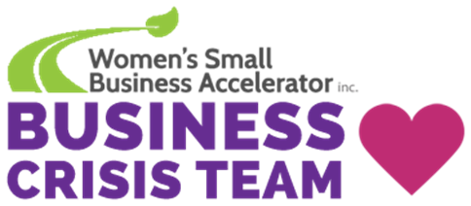

Business owners in need are hand-matched with the Business Crisis Team mentor best suited to help with their specific concerns and issues. Mentoring discussions take place online or by phone and business owners can use this resource free of charge.

“This is a scary time for business owners who are facing layoffs and having their revenue abruptly stopped.” said Mary McCarthy, WSBA’s President and CEO. “For a business in crisis, not only do we want them to know they are not alone, but we want to help them find something to look forward to on the other side of this pandemic.“

Business owners that wish to engage the WSBA Business Crisis Team can request assistance at WSBAOhio.org/BusinessCrisisTeam. Business leaders that want to help other business owners can become a volunteer mentor at the same site.

About The WSBA:
The Women’s Small Business Accelerator (WSBA) is a non-profit accelerator founded by successful women business owners for women business owners. The organization provides support to Central Ohio women business owners in every stage of their business. Through education, mentoring, and accountability the WSBA helps women on their entrepreneurial journey to start and grow their own businesses.

###

